UNIVERSITY STUDENT mental ISSUES ANALYSICS
MCBI61: Handling and Interpreting Data for Decision Making: September 2025(09-BI61-MKPMW-25)
CHENTONG WANG 737217446

November 23, 2025

Table of Content
1. Introduction 2
2. Business Scenario 3
2.1. Business Question 3
3. Business Problem Evaluation 5
3.1. Ethical and Cultural Aspects 5
4. Data 6
4.1. Applicability of Data 6
5. Data Wrangling 7
6. Summary 12
7. References 13
8. Appendix 14

Introduction

If we classify humans into societal groups, university students represent a distinct demographic. Typically, over the age of 18, they often lack extensive social experience, which necessitates specific support and protection. Society provides this support through various channels, focusing on their education, career development, and overall mental and physical well-being.

The mental health of university students is a priority for societies and educational departments worldwide. Many governments allocate significant funding for psychological counselling and the enhancement of mental health infrastructure. Universities further bolster this support by establishing dedicated departments and hosting regular workshops and lectures aimed at raising student awareness.

However, the prevalence of mental health issues among university students is rising at an alarming rate globally. To investigate the root causes of problems such as anxiety, stress, and depression, relevant departments have collected student feedback. This data encompasses attitudes toward financial background, academic majors, gender, academic levels, grades, and the presence of negative emotional traits.

This report aims to analyze this business problem using the provided database, leveraging Microsoft Excel, Power Query, and Power Pivot. The goal is to provide clear insights and actionable recommendations for effectively reducing the incidence of mental health issues among university students.

Let us begin the project with a business scenario focused on the mental health of university students.

Business Scenario

Mental health is an expression of human emotions. Determining whether an individual has any mental health issues involves observing their ability to address emotions (such as family stress, depression, anxiety, etc.) in daily life, their contributions to the community, and their performance in learning and work (World Health Organization, n.d.). Mental health issues can cause significant physical and psychological damage. Many individuals tend to overlook mental health problems initially, as they may not affect daily life at first, but they can ultimately disrupt one’s everyday functioning when negative emotions become severe.

The Psychological Health Association has recognized the importance of exploring the factors that impact the mental health of university students. Research indicates that a significant percentage of college students struggle with mental health challenges, with some studies estimating that nearly 12-50% of students experience at least one mental health issue during their academic careers. These issues not only hinder academic performance and daily life but may also lead to higher dropout rates (Pomerantz & Kauffman, 2005).

Conducting in-depth research in this field is essential, as mental health issues can have numerous negative effects. This report aims to identify the causes of psychological issues among students by analyzing the dataset. The findings of this report will provide data evidence for further research.

This report will achieve the following objectives below:
- Show the impact of personal circumstances on various mental issues.
- Identify the key elements of causing any mental issues.
- Provide suggestions on alleviating psychological problems of university students.

Business Question

High-Level Business Questions:
- What is the main reason of causing mental issues for university students?
Low-Level Business Questions:
- What are mental issues analysed at the dataset?
- How can we define that students have the mental issue and how serious they are?
- Where are these students from?
- Can their majority be the main reason causing mental issues?
- Do different causes result in different mental issues?

Business Problem Evaluation

The Psychological Association aims to obtain positive feedback by analyzing the factors influencing the mental health of university students, thereby helping them make better decisions and providing data support and theoretical foundations for the development of new psychological treatment programs in the future.

Additionally, mental health issues among university students are also a focus for the government. Analyzing this data can help the nation accurately identify problems, continuously update policies, and improve citizens' overall life satisfaction.

Ethical and Cultural Aspects

The data has been sourced from the Kaggle platform, specifically the "Students' Mental Health" dataset. Kaggle datasets are considered open data sources, meaning that all data from the platform is public and non-private. The dataset used for this report focuses on university students in Bangladesh and is not intended to identify any specific populations or racial groups. Additionally, there are no cultural or ethical issues associated with the dataset.

Data

Dataset used for analysis obtains from Kaggle, see the link below:
https://www.kaggle.com/datasets/malakelhawaryyy/university-students-mental-health

Applicability of Data

The dataset with 1977 rows and 39 columns is from universities of Bangladesh. It collects the personal information of universities’ students including ages, genders, names of institutions, departments, academic years, current CGPAs, situations of waiver or scholarship. The information about personal situations can be defined as elements that may cause any psychological issues. By evaluating their feelings and presentations against a clinic scale, they can be diagnosed the specific categories of psychological conditions. The business problem can be solved through leveraging data analysis technology.

This dataset is comprehensive, as it collects student feedback on three major psychological issues (anxiety, stress, depression), making the conclusions relatively valuable for reference. The included basic information about students is also well-organized, allowing for classification based on economic situation, personal characteristics, and academic direction—three significant aspects that greatly impact students. By examining these factors, it's possible to identify the causes influencing mental health.

However, this dataset is specific to a particular country, and due to differences in national circumstances, the conclusions drawn from this data should only serve as a reference and cannot be fully generalized. Future applications should be adjusted based on the specific conditions of different countries.

Data Wrangling

Data wrangling is a process of cleaning, addressing, structuring raw data to guarantee the suitability of data for subsequent analysis. This is an important step for data analysis. As known data preparation, most of the raw dataset can be messy, inconsistent, unsuitable for using. So, data wrangling is an initial step to support high-quality dataset through transforming raw datasets into be reliable, consistent and clean. Data wrangling can help data scientists, data analysts and other business user to use data and figure out other data-driven applications. (IBM, n.d.)

The steps of data cleaning and data wrangling showing below:
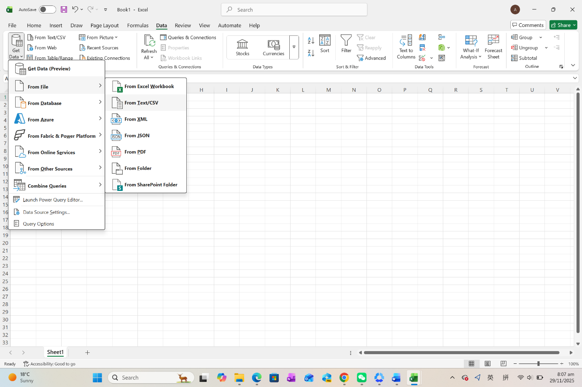
- Open a blanket workbook, save as “assessment1 dataset”, and find “data” on workboard, click “get data”, hover over on “From File”, then click "From Text/CSV”.
- Select “Transform Data”.
- Scroll through to do a quick check any issues, e.g. check the data type of any column, the column name.
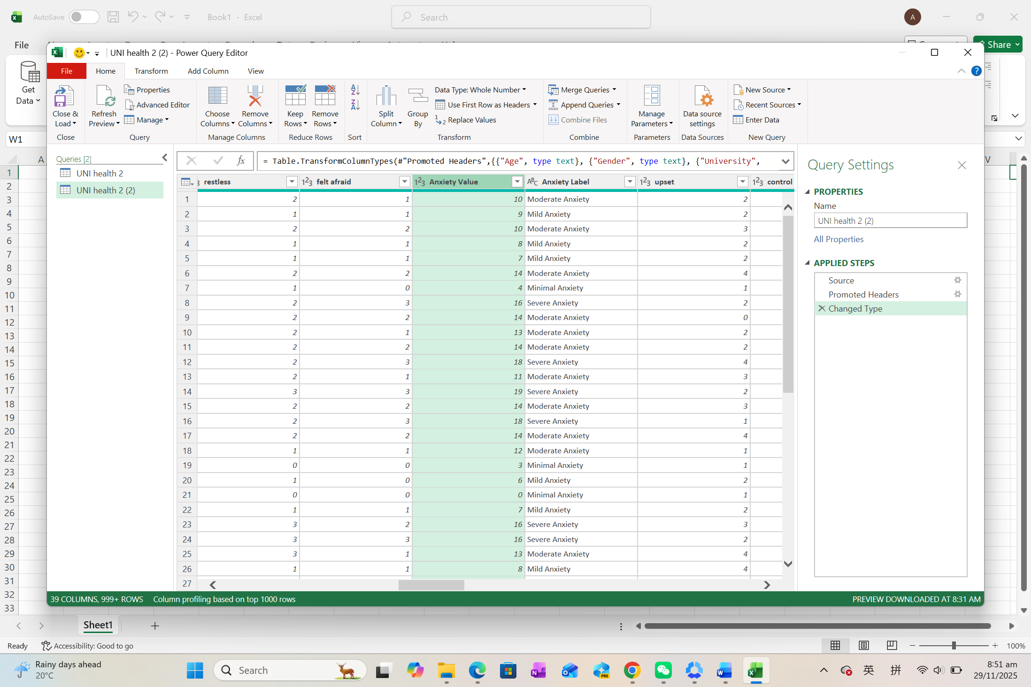
- Select “Column Quality Check” to make sure the quality of data is 100% valid.
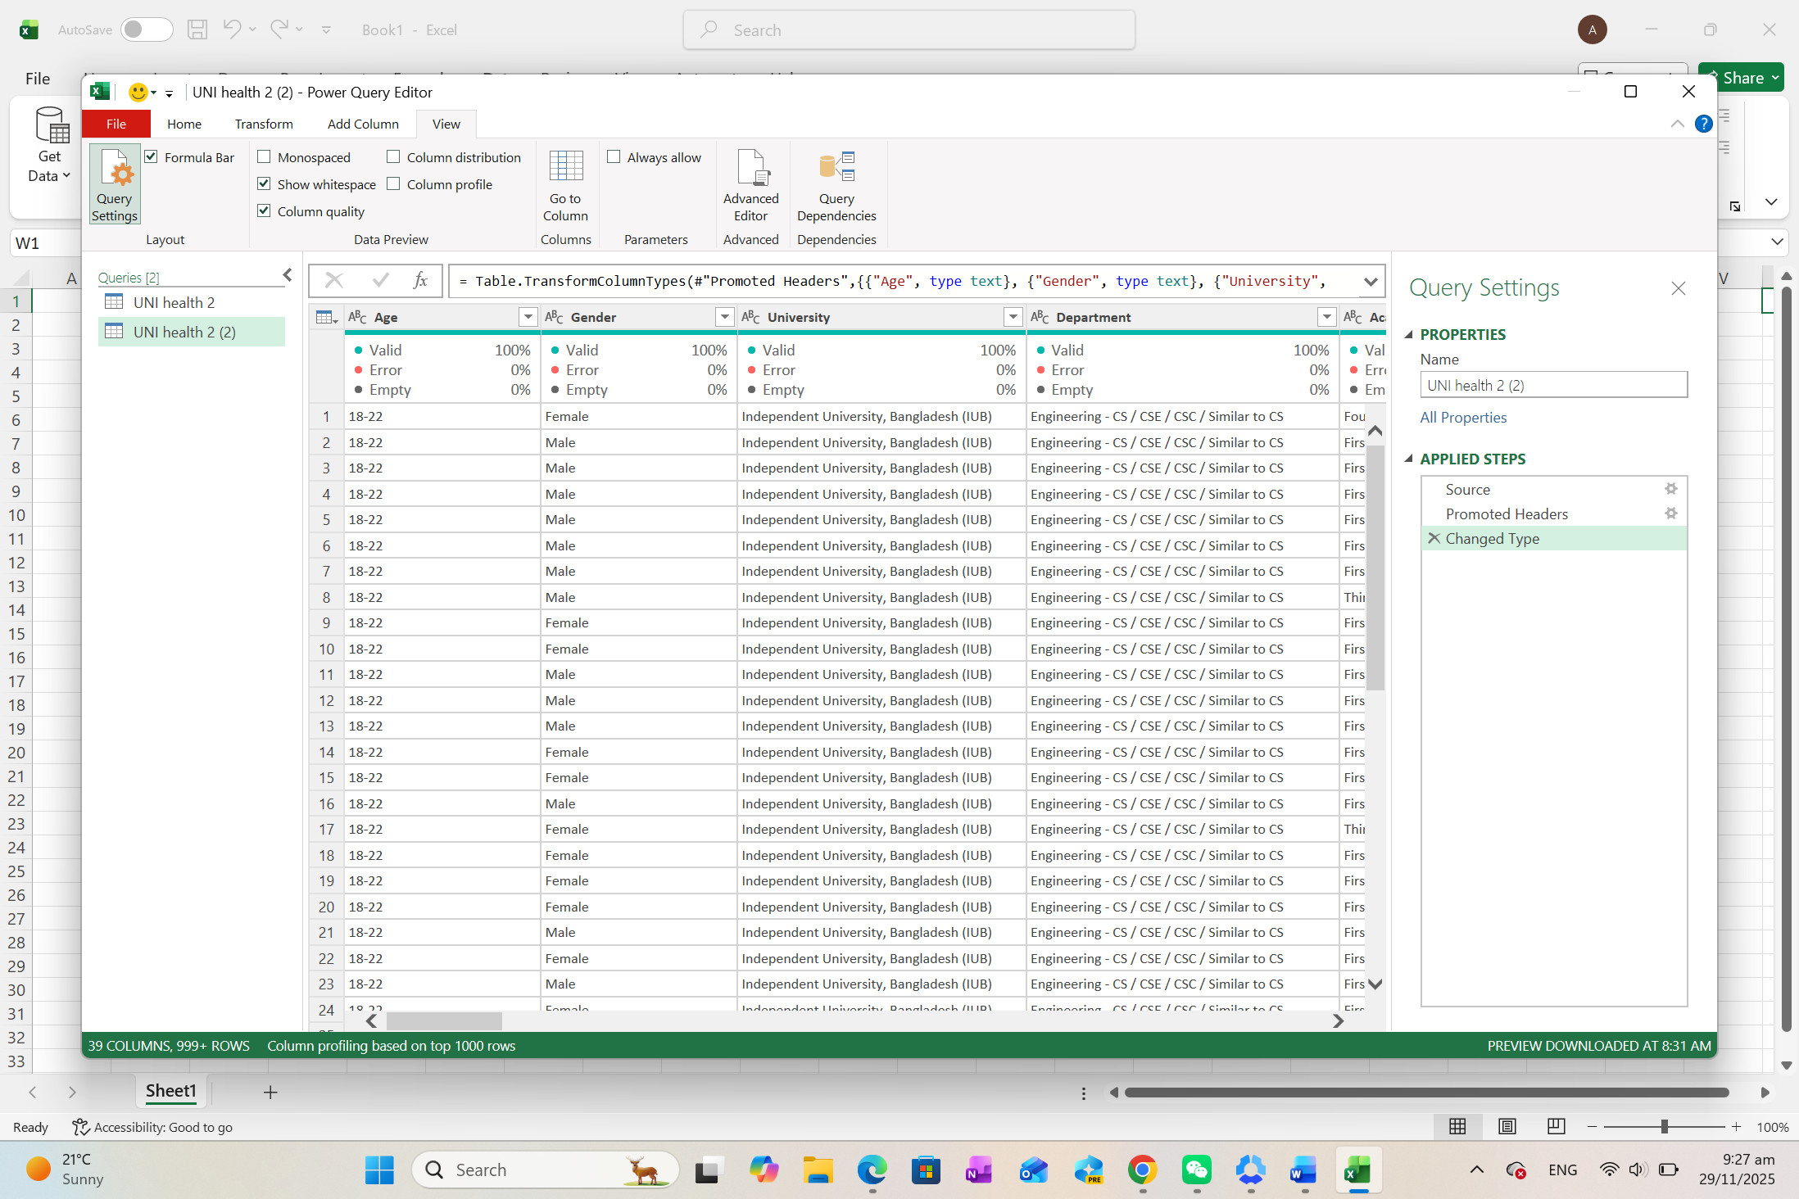
- Check every column if it has null or other mistakes. In this progressing, these are some issues be found.
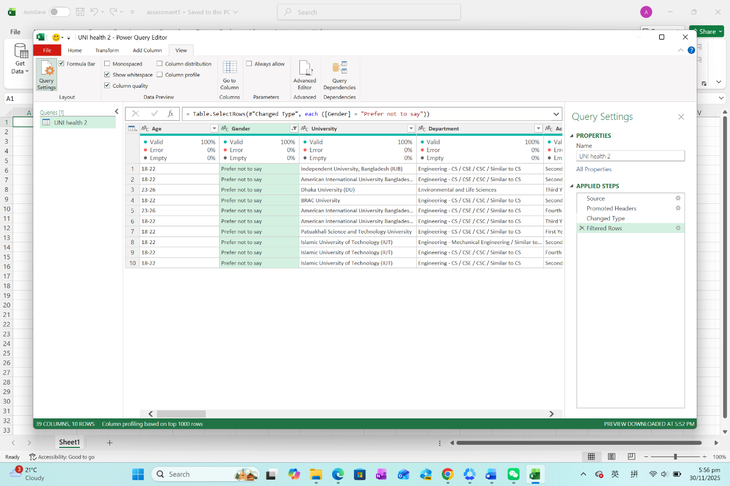
  - At column “Gender”, the selection of “prefer not to say” appears 10 rows, only 0.5% of all rows (total 1977 rows), which will not affect the result, so these rows will be persisted.

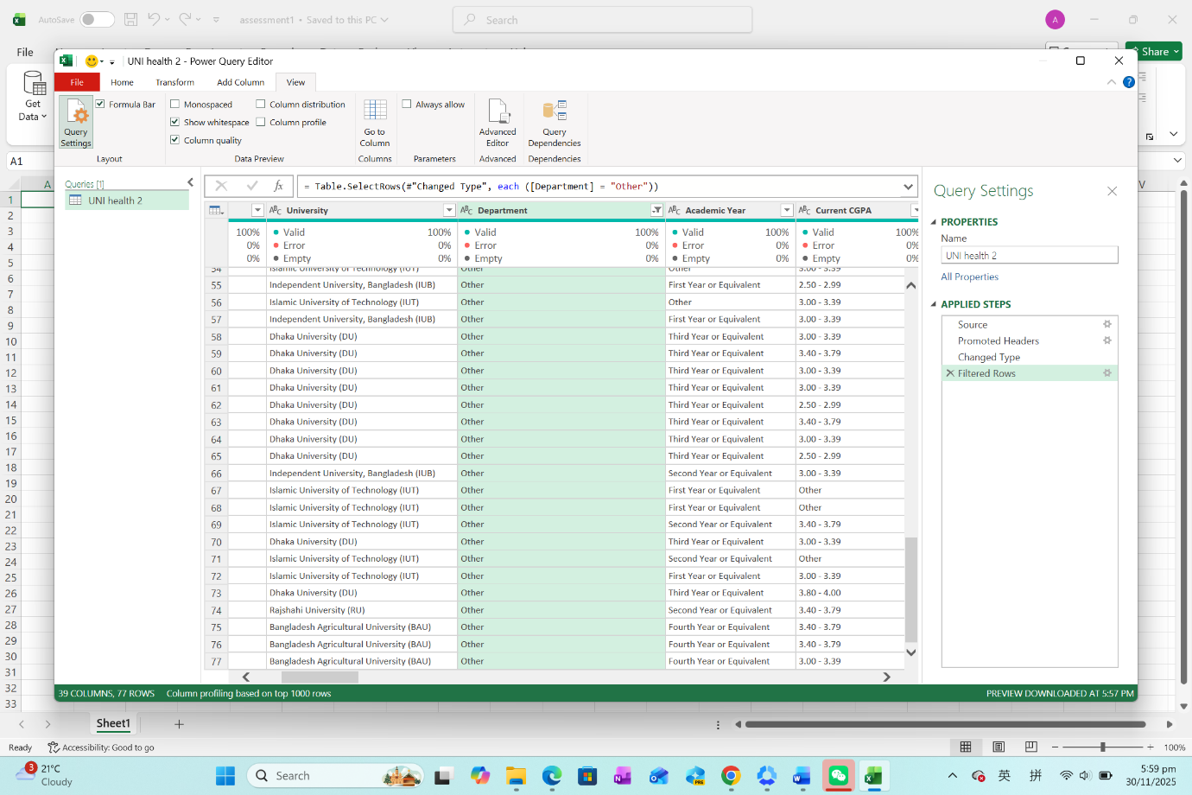
  - At column “Department”, the selection of “Other” is 77 rows, which is 3.8% of all rows, which will not affect the result, so these rows will be persisted.

  - At column “Academic year”, the selection of “Other” is 71 rows, which is 3.6% of all rows, which will not affect the result, so these rows will be persisted.

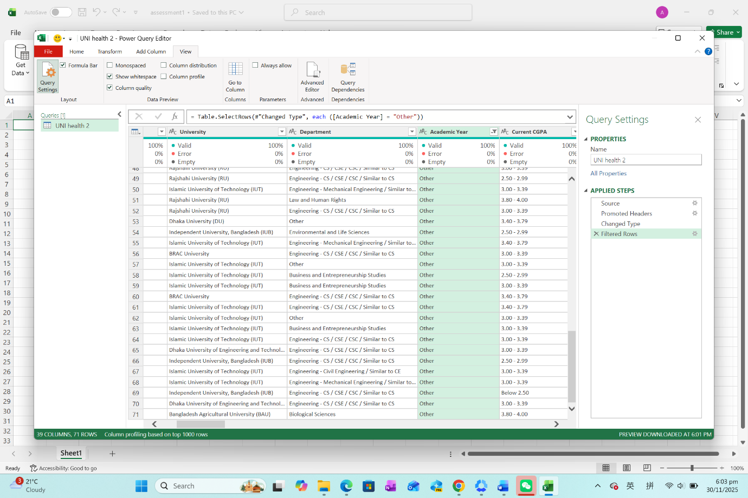

  - At column “CGPA”, the selection of “Other” is 168 rows, which is 8.45% of all rows, which is over 5%, so the conclusion of the effect of CGPA may cause deviation.

- Rename the Power Query to “university student mental issue”;
- Click ”Close and Load” to load into spreadsheet.
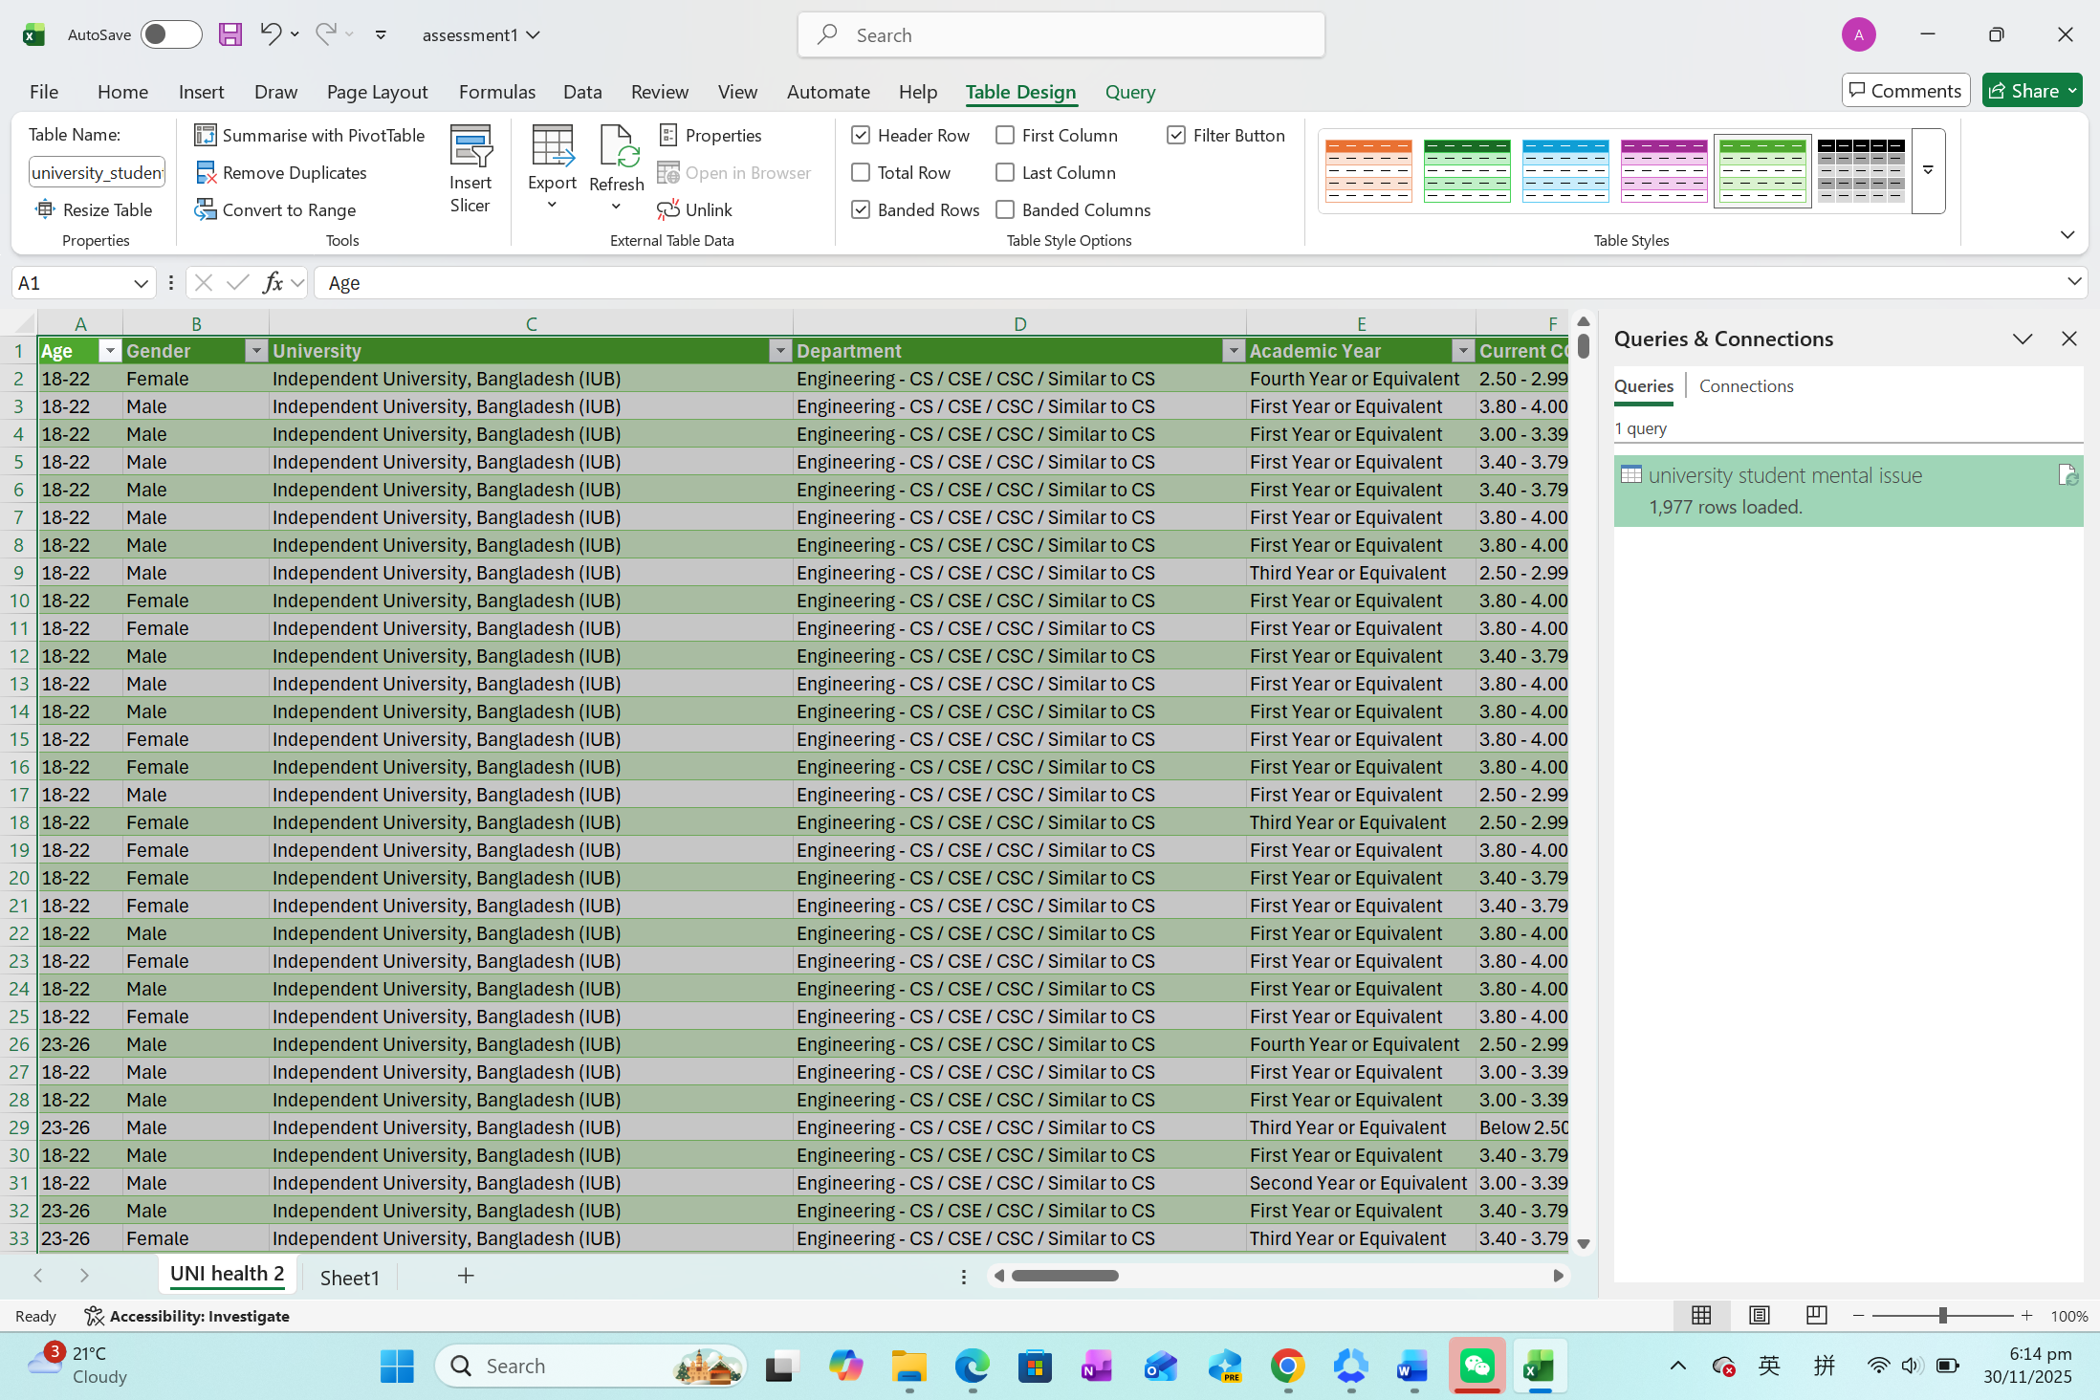

Summary

In conclusion, the dataset is relatively comprehensive. However, since it is gathered in a format like a survey questionnaire, there may be definitive options (e.g. department, gender, academic year) that account for a relatively small percentage. This is unlikely to have a significant impact on the analysis results.

The dataset has finished the step of data cleaning and can be used to further analysis.

References

- World Health Organization. (n.d.). Mental health: Strengthening our response. Retrieved from http://who.int/news-room/fact-sheets/detail/mental-health-strengthening-our-response
- Pomerantz, A. M., & Kauffman, J. (2005). The role of coping in the mental health of college students. PMC. Retrieved from https://pmc.ncbi.nlm.nih.gov/articles/PMC12213389/
- IBM. (n.d.). Data wrangling: The key to data-driven decisions. Retrieved from https://www.ibm.com/think/topics/data-wrangling

Appendix
About the dataset:
